* **A CUSTOMARY LAND CONFLICT RESOLUTION PROCESS UNDER THE ASAFO LAND SECRETARIAT**

**Poku Appiagyei KWABENA,** **Elisha Akanlo Anankansa and Dr. Emmanuel Offei AKROFIE**

**Keywords:** Customary land disputes, Asafo Stool Lands, Spatial analysis, Conflict resolution techniques, Demographic factors in conflict resolution

# Summary

Customary land disputes in Ghana's Traditional Stool Lands pose a complex problem with significant socio-economic and cultural consequences. This study aims to investigate the complexities of land conflicts under Asafo Stool Lands and how they can be resolved. The study utilized a mixed-method approach, combining both qualitative and quantitative methods with spatial analysis, to thoroughly investigate land conflict issues in specific towns. The data analysis prioritized detailed interpretation, employing content analysis to comprehensively understand complex land conflict scenarios in the study area. This approach facilitated a deep exploration of both the conflicts and their spatial context. The study explored community preferences for conflict resolution techniques, revealing mediation as the most popular option and demonstrating cultural preferences for collaboration. Demographic factors such as gender, age, and educational background exhibited nuanced impacts on these preferences. Using a Likert scale, we explored the effectiveness of existing conflict resolution processes. Although most respondents expressed comfort with the transparency of decision-making procedures, concerns arise regarding the representation of vulnerable or marginalized groups. This highlights a crucial area for improvement. Stakeholder interviews amplify these findings, emphasizing the need for improved communication and sensitivity to diverse community needs. The study also incorporated spatial analysis to uncover the geographic nuances of land conflicts. The Global Moran’s I statistic indicated a dispersed pattern of conflicts, challenging assumptions of uniform spatial distribution. Notably, specific areas like Atwima Darko emerged as a conflict hotspot zone, demanding targeted interventions. These spatial patterns revealed a dynamic landscape of conflict, emphasizing the need for tailored strategies. Findings indicate that education levels significantly influence the choice of resolution mechanisms, calling for tailored training programs. Additionally, localized interventions should be prioritized based on spatial characteristics, with a special focus on identified hotspots. The inclusion of marginalized groups in the resolution process remains crucial. This research offers a crucial resource for refining conflict resolution strategies within the Asafo Traditional Stool Lands, highlighting the necessity for nuanced, data-driven approaches to address this intricate socio-cultural issue.

# 1.0 INTRODUCTION

Land conflict, with its intricate historical, cultural, and socio-economic roots, has been a global concern affecting shelter, agriculture, industry, and cultural identity (UNHCR, 2015). The complexity of this issue is magnified in Africa, where historical colonization, diverse land tenure systems, and competition for finite resources fuel conflicts, as seen in countries like Kenya, Zimbabwe, and South Africa (Lund, 2008; Moyo, 2000; Peters, 2004). In the context of Ghana, particularly the Asafo stool lands, land transcends an economic resource and becomes an integral part of cultural identity, governed by customary laws (Aryeetey et al., 2007). Conflicts emanating from disputes over ownership, boundaries, and land use have led to community disruptions and violence (Kasanga & Kotey, 2001). While traditional mechanisms like mediation by chiefs and elders have been employed, challenges persist due to modern complexities, urbanization, and the waning influence of traditional authorities (Crook, 2005; Kalabamu, 2021). Furthermore, the authority of chiefs in land ownership transfer in the Western Regions of Ghana, as highlighted by Boone and Duku (2012), has resulted in a multitude of conflicts. These issues underscore the interwoven statutory and customary laws that add to disputes and uncertainties around land tenure. Understanding the land conflict resolution within Traditional Stool Lands requires a nuanced examination of these global, African, and Ghanaian intricacies, paving the way for insights and strategies to foster peace, stability, and sustainable development. Customary land involves various actors such as government officials, traditional leaders, family heads, communities, and individuals, and embodies different perspectives and interests (Aryeetey et al., 2007). These dynamics contribute to the rich and complex tapestry of land-related struggles in the region, reflecting the wider historical and contemporary challenges faced worldwide. Land disputes are multifaceted, arising between various ethnic groups, chiefs, and subjects, or even within families. As land is a finite and valuable resource, essential to human settlements, agriculture, and economic activities, conflicts over access, ownership, and usage are often intricate and enduring. The situation can further escalate into violent confrontations, resulting in loss of life and property, and disrupting regular socio-economic activities (Kalabamu, 2021). Resolving these land-related conflicts is a challenging task that requires a thorough understanding of the underlying causes, as well as a commitment to openness, justice, accountability, negotiation, and compromise (Oppong-Kusi, 2019). Although traditional customary courts, mediation, and negotiation are commonly employed in the region, they have faced criticism for their limited capacity to manage complex disputes. This limitation stems from the absence of necessary technical expertise, resources, and a coherent legal framework (Crook, 2005). The situation is further complicated within the Western Regions of Ghana, where chiefs wield substantial authority over land ownership and arrangements, leading to a proliferation of land conflicts (Boone & Duku, 2012). Such conflicts often culminate in a "win-lose" outcome, creating an imbalance in interests and undermining the fairness of resolutions (Ajayi & Buhari, 2014). Conflict resolution, therefore, seeks balanced solutions that consider the underlying concerns and interests of all parties involved. The complexities of land tenure within these traditional lands emphasize the necessity for a comprehensive understanding of the nature and dynamics of land disputes (Aryeetey & Urdry, 2010). Insecurity in land tenure can lead to reduced investment, productivity, and growth, adding another layer of complexity to the rural economies within Ghana's traditional stool lands. The synthesis of these factors highlights the profound challenges of land conflict resolution in the Traditional Stool Lands and underscores the need for an integrated approach that embraces both modern legal frameworks and traditional wisdom.

## 1.1 Statement of the Problem

The problem of land conflict is a global concern, reflecting complex socio-economic and cultural dynamics (Deininger, 2003; UNHCR, 2015). In the African context, this issue is further complicated by historical colonization, diverse land tenure systems, and competition for finite resources (Lund, 2008; Moyo, 2000; Peters, 2004). Specifically, within Ghana, and more acutely Traditional Stool Lands, land conflicts represent a critical challenge. These conflicts arise from various intricacies including disputes between different ethnic groups, chiefs, subjects, and family members over ownership, access, and land use, often escalating into violence (Kasanga & Kotey, 2001; Kalabamu, 2021). The existing mechanisms for conflict resolution, including traditional customary courts and mediation, have faced limitations in handling these complex disputes (Crook, 2005). This combination of global, African, and specifically Ghanaian dimensions highlights a multifaceted problem that necessitates an integrated approach for effective resolution in the Asafo Traditional Stool Lands, balancing modern legal frameworks with traditional wisdom, to promote peace, stability, and sustainable development. Land conflicts, a longstanding global dilemma with significant economic, social, and environmental ramifications, are particularly complex to resolve. This complexity necessitates a multifaceted approach, encompassing an understanding of the conflict's underlying causes, ensuring appropriate legal and institutional structures, and advocating for sustainable land management practices. The intricacies of resolving such conflicts often call for the collaboration of various stakeholders, including governmental bodies, civil society, and local communities. However, the lack of capacity, resources, and political determination frequently lead to extended, sometimes violent disputes (UNEP, 2017). In the context of Africa, and specifically the Asafo Traditional Stool Lands in Ghana, the existing literature reveals a noticeable gap. Current research either tends to generalize African land conflicts or focuses solely on wider Ghanaian issues, neglecting the unique subtleties of customary laws and traditional mechanisms in this specific region (Ajayi & Buhari, 2014; Aryeetey & Urdry, 2010). Furthermore, contemporary studies often overlook the possible integration of modern legal tactics with conventional wisdom in conflict resolution.

This study aims to fill this research gap by conducting a comprehensive examination of customary land conflict resolution in the Asafo Traditional Stool Lands. It seeks to assess the efficacy of prevailing traditional methods, explore the complex relationship between statutory and customary laws, and propose innovative resolutions that accommodate the concerns and interests of all involved parties. In bridging this research gap, the study endeavors to enrich the understanding of land conflicts in this region, providing more insights and strategies with potential applicability to other traditional lands in Ghana and analogous situations across the African continent.

**1.2 Aim and Objectives**

## Aim

This study aims to assess the effectiveness and suggest improvements to the customary land conflict resolution processes under the Asafo Traditional stool lands.

## Objectives

1. To identify community preferences on land conflict resolution mechanisms.
2. To assess effective conflict resolution processes.
3. To perform some spatial analysis to show conflict-prone areas under the study area.

## 1.3 Scope of the Study

The contextual and geographical scope of the study is focused on specific regions of the Atwima Kwanwoma district within Ghana. These traditional stool lands, situated in the Ashanti Region, are marked by a significant cultural and economic role in local communities. The study will explore the complex nature of customary land conflicts within these lands, considering both historical and contemporary dimensions. This includes an in-depth examination of land tenure systems, the role of chiefs and local authorities, intertwined statutory and customary laws, and the dynamics between different stakeholders such as ethnic groups and families. Conflict resolution mechanisms like traditional courts, mediation, and negotiation will be assessed for their effectiveness and potential areas for improvement. The geographical landscape, comprising both rural and urban settings, will be taken into account to understand varying land conflict characteristics. Emphasis will be on understanding the relationship between modern legal strategies and traditional wisdom in conflict resolution, and how these can be integrated effectively.

.

## 1.4 Study Area

Delta Situated centrally within the Ashanti Region, the Atwima Kwanwoma District occupies a geographical area of 251.9 square kilometers—representing about 1.03% of the region's total expanse of 24,389 square kilometers. The district's administrative capital, Atwima Twedie, is strategically located at a distance of approximately 18 kilometers from Kumasi. Geopolitically, it is bounded by Kwadaso Municipal to the north, Bosomtwe District to the east, Atwima Nwabiagya Municipal to the west, and Amansie West District to the southwest. According to the 2021 Population and Housing Census, the district has a population of 234,846, with a gender distribution of 114,123 males and 120,723 females (PHC, 2021). Geographically, it is positioned between latitudes 6.24°N and 6.43°S and longitudes 1.15°W and 1.46°E.

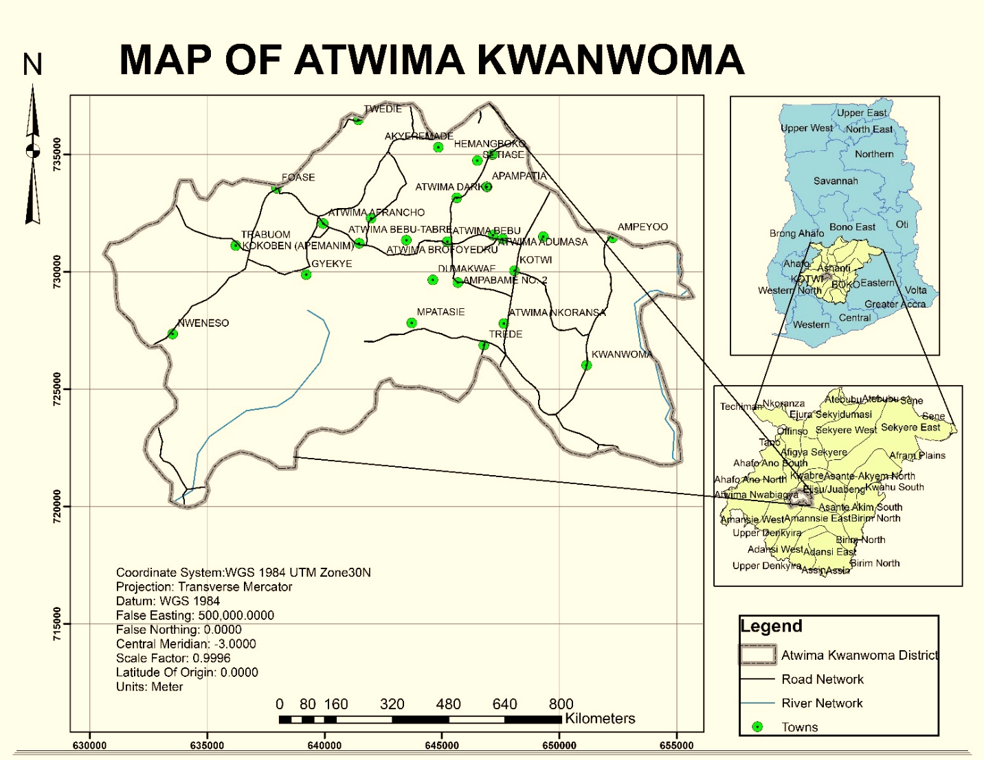

Figure 1.0: Study Area

The district plays a vital role in agriculture, constituting a significant avenue for output, income, and employment within the region. Nearly 62.6% of the district's workforce is engaged in agriculture, primarily in small-scale traditional farming practices (MOFA Office, 2009). This agricultural prominence is supported by the district's ecological makeup, characterized by abundant arable land, forest resources, and favorable climatic conditions conducive to the cultivation of a myriad of crops, including maize, cassava, yam, and various commercial tree crops like cocoa and citrus. Additionally, the district's proximity to Kumasi provides farmers with convenient access to a robust market for their produce. The district was purposefully selected as the study area for its significant agricultural focus, employing approximately 62% of the local labor force as per the Population and Housing Census Report of 2000. This makes the Atwima Kwanwoma District one of the rapidly developing districts in the Ashanti Region, and an ideal setting for exploring community preferences and effective methods for land conflict resolution

## 2.0 LITERATURE REVIEW

Land disputes are a pervasive and complex phenomenon that affects the livelihoods, security, and environment of millions of people around the world. Resolving land disputes is a challenging task that requires a multidisciplinary and context-specific approach, involving both theoretical and empirical insights. This study aims to provide a comprehensive and integrative overview of the literature on land disputes and their resolution, with a particular focus on the case of Ghana and the use of spatial analysis. The theoretical framework that guides the analysis of land disputes and their resolution introduces the Conflict Cycle model, proposed by Zartman (2000), which describes the stages of conflict escalation and de-escalation, as well as the opportunities and challenges for negotiation and resolution. Alternative Dispute Resolution (ADR), is a form of non-violent and participatory conflict resolution, and how it is implemented in Ghana, drawing on the empirical study of Ibrahim et al. (2022) on the ADR committees in the Upper West Region. The study compares and contrasts the customary and modern court systems in Ghana, which coexist and compete in resolving land disputes, highlighting the differences in the roles of chiefs, cross-examination practices, and trial procedures, based on the comparative analysis of Morton (2016). Hidalgo et al. (2010) and Deininger and Castagnini (2006). Posited some of the main causes and effects of land conflicts, such as competition for resources, displacement, and environmental degradation, which also incorporates other theoretical perspectives and frameworks that have been applied to the study of land disputes and their resolution, such as the political ecology approach by Robbins (2012), the institutional analysis by Ostrom (2005), and the human rights perspective by UN-Habitat (2009). The study introduces the spatial methods that can be used to analyze and visualize the patterns and dynamics of land disputes. It explains the concepts and measures of global and local spatial autocorrelation, such as Moran’s I, Geary’s C, and Local Indicators of Spatial Association (LISA), and how they can reveal the spatial dependence and heterogeneity of land disputes. The study also describes the methods and indicators of spatial distribution, central tendency, and dispersion, such as the Nearest Neighbor Index (NNI) and petrographic statistics, and how they can capture the spatial variation and concentration of land disputes. Moreover, the study illustrates the different mapping techniques that can be applied to identify and display the hotspots and spatial patterns of land disputes, such as Point Mapping and Kernel Density Estimation (KDE), noting the advantages of KDE over Point Mapping in representing hotspots as continuous smooth-density surfaces. It also discusses the advantages and limitations of spatial analysis, as well as the data sources and software tools that can be used for spatial analysis, such as satellite imagery, GIS, and R. The study reviews some of the empirical studies that have applied spatial analysis to examine land disputes and their resolution, such as Kidido & Bugri’s (2020) research in Ghana and Golar et al.'s (2021) study in Indonesia. The study summarizes the main findings and implications of these studies, as well as their limitations and challenges, such as geographic scope, sampling methods, and potential biases. It also identifies the gaps and directions for future research in this field, such as the need for more comparative and longitudinal studies, the integration of qualitative and quantitative methods, and the inclusion of gender and power dimensions. It also provides some examples of other empirical studies that have used spatial analysis to study land disputes and their resolution in different contexts, such as the studies by Ali et al. (2017) in Pakistan, Ayalew et al. (2012) in Ethiopia, and D’Odorico et al. (2017) in Kenya.

## 3.0 METHODOLOGY

The research was conducted across selected towns within the Atwima Kwanwoma District, falling under the jurisdiction of the Asafo Stool Lands. Governed by the Asafo Lands Secretariat, these lands offer a huge context for evaluating community perspectives on conflict resolution. Utilizing a mixed-method approach that combines both qualitative and quantitative research methods, the study scrutinizes data from 20 strategically chosen towns.

**3.1 Research Design**

In outlining the research design for this study, a mixed-method approach combining both qualitative and quantitative methodologies was utilized to effectively address the research objectives. Complementing these approaches, spatial analysis was incorporated to enrich the study's comprehensiveness, given the geographically specific nature of the research focus. This addition enables an intricate analysis of spatial patterns, correlations, and distributions associated with land conflict issues in the selected towns. For a visual overview of the methodology (See Figure 1.0). The chosen data analysis technique was primarily descriptive in nature, designed to offer an exhaustive interpretation of the data collected, spanning both spatial and quantitative/qualitative elements. Content analysis was employed to scrutinize both types of data, facilitating a robust understanding of the complex land conflict scenarios in the study area. This integrative methodology not only provides depth in understanding the conflicts but also allows for an expansive exploration of their spatial context.

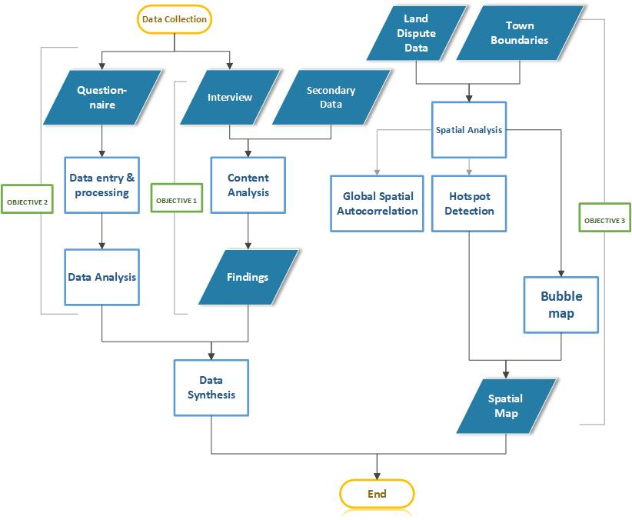

Figure 2.0: Methodological flowchart

**3.2 Sampling procedure**

A sample, from a statistical viewpoint, serves as a subset of a larger population and is chosen for detailed examination. This chosen subset allows for the estimation of fundamental characteristics of the broader population, such as means, proportions, and variances (Fowler, 2013). For the purpose of this study, the unit of analysis included community members, traditional leaders (Chiefs), and other relevant stakeholders who have a direct bearing on the subject matter of land conflicts. To secure participants capable of providing insightful data, we employed purposive sampling, a non-probability sampling technique. This technique is particularly effective in qualitative research where the objective is to obtain a rich, in-depth understanding of a specific group or phenomenon. The application of purposive sampling was ideal for capturing nuanced qualitative responses, thereby facilitating deeper insights and more accurate findings related to the complex issue of land conflicts. Non-probability methods excel in capturing the intricacies of complex social phenomena, as emphasized by Small (2009). One of the key benefits of adopting non-probability sampling in this study was its efficiency. It provided a fast, straightforward, and cost-effective way of data collection without the need for a comprehensive survey framework (Gyamera et al., 2006).

**3.3 Sampling size**

A total of 200 respondents were surveyed through questionnaires, with a stratified approach that saw an average of 10 respondents selected from each of the 20 targeted towns. This sample size was strategically determined to enable robust generalization of the research findings and to draw conclusive insights. The surveyed respondents primarily consisted of individuals who have been directly impacted by land conflicts. For the interview component of the study, a smaller but more specialized sample of 20 respondents was interviewed. These participants were carefully chosen based on their roles and influence within the community and included traditional leaders like chiefs and elders, as well as family heads. Additionally, key informants from various institutions were included to provide a diversified perspective. The rationale behind involving these particular individuals was to harness in-depth insights from stakeholders who hold significant knowledge, influence, and decision-making power in the community context. The inclusion of these participants was deliberate and designed to yield crucial perspectives and experiences that are instrumental for understanding and addressing the complex issues surrounding land conflicts. Through this sampling strategy, the study aimed to unearth valuable insights concerning the root causes, impacts, and prospective solutions for land conflicts in the study area.

**3.4 Data collection and procedures**

In this study, a comprehensive approach was adopted, utilizing two primary data collection techniques to gather a robust dataset. Firstly, standardized questionnaires were administered to participants, facilitating consistent responses to specific inquiries. The questionnaire, meticulously crafted to align with the research objectives, encompassed various sections and was designed in a close-ended format. Additionally, personal interviews were conducted, serving as a crucial component of the research methodology. Through these interviews, the researcher engaged in profound discussions, thereby capturing qualitative insights that might not be attainable through questionnaires alone. These interviews provided a nuanced perspective on land-related conflicts and the mechanisms employed for dispute resolution. Notably, the interview process was augmented by involving key stakeholders with expertise in the subject matter. These individuals included representatives from the Lands Commission and District Assembly, representing governmental bodies, the Asafo Customary Land Secretariat, the Asantehene Land Secretariat, and the House of Chiefs, representing the traditional authority. The selection of these key informants was strategic, aiming to glean valuable insights from those with deep knowledge of the intricacies of land conflict issues. Secondary data, predominantly sourced from these institutions, was focused primarily on land conflicts among individuals, groups, stools as well as others. This secondary data played a significant role in facilitating the spatial analysis segment of the study, wherein the geographical aspects of the conflicts were explored. This integrative approach, spanning questionnaires, interviews, and spatial analysis, enabled a comprehensive exploration of the multifaceted dimensions of land conflicts within the study area.

**3.5 Data Analysis and Processing**

The use of Excel, a widely adopted software for data manipulation, played a pivotal role in structuring the information derived from the questionnaires. The data collected from various sources were meticulously organized and prepared for subsequent analysis using Excel's comprehensive features. Subsequent to the data collection phase, a systematic process of coding and processing was undertaken. For this purpose, the Statistical Package for Social Sciences (SPSS), a versatile software extensively used in research, was employed. Through the application of SPSS, a suite of descriptive statistical techniques was employed, encompassing the calculation of means, generation of frequency tables, determination of variable percentages, and execution of multiple regression analyses. These techniques collectively empowered a profound understanding of the dataset, aiding in the extraction of insights and conclusions from the collected data. Spatial analysis was conducted using the ArcGIS Software, a robust tool renowned for its spatial data processing capabilities. Hotspot maps and kernel density maps were generated using ArcGIS, enabling a visual representation of spatial trends and patterns within the collected data. By utilizing a combination of powerful software tools, this research journey harnessed the capabilities of ArcGIS, Excel, and SPSS to seamlessly progress from data collection to insightful analysis, facilitating a comprehensive exploration of the research questions at hand.

**3.6 Spatial data preparation**

A systematic approach was adopted to integrate town boundaries and land conflict case data. This preparation ensured accurate spatial representation and contextualization of the conflict incidents within their respective administrative regions. Key datasets were collected, the first containing spatial information about land conflict case locations, and the second comprising town boundary shapefiles. Ensuring proper georeferencing and alignment of both datasets to a consistent coordinate system was crucial for accurate spatial analysis and visualization. Attribute data from the land conflict case dataset, which included information about the number of cases at each location, was integrated, allowing the incorporation of case density information into the spatial analysis. By utilizing ArcGIS, the town boundary shapefiles were imported into the project. These shapefiles defined the administrative boundaries of towns, thereby establishing the geographical context of conflict incidents.

**3.7 Spatial Analysis Techniques**

The utilization of hotspot analysis and kernel density estimation, incorporating land conflict data count and town boundaries, formed the core of the spatial analysis methodology.

**3.7.1 Hotspot Detection**

Hotspot analysis involved identifying areas of statistically significant clustering or dispersion of land conflict incidents within the context of town boundaries. Land conflict data, containing incident counts and corresponding geographic locations, were integrated with town boundary shapefiles within the ArcGIS environment. Computation of the Getis-Ord Gi* statistic was conducted in ArcGIS, considering the incident count as the attribute for analysis. The statistics facilitated the identification of statistically significant hotspots (areas with high incident counts surrounded by other high-count areas) and cold spots (areas with low incident counts surrounded by other low-count areas). Calculation of Global Moran's I was carried out in ArcGIS to indicate the pattern within the data, factoring in incident counts and spatial relationships within town boundaries. The results of hotspot analysis were translated into thematic maps generated in ArcGIS. These maps visually portrayed the distribution of hotspots, cold spots, and spatially significant clusters of land conflict incidents within town boundaries.

**3.7.2 Bubble map**

Spatial analysis using bubble maps is a powerful technique that allows researchers and analysts to visualize and understand data in a geographic context. Bubble maps use varying sizes or colors of bubbles to represent data points on a map, making it easier to discern patterns and trends. A bubble map visualization combines elements of a bubble chart with a geographical map. This type of chart is effective for highlighting particular data values in relation to geographic locations. It provides a spatial context that can uncover insights that might not be apparent through traditional data analysis methods and relationships within the data.

## 4.4 Discussion of results

**Objective 1: Community Preferences on Conflict Resolution Mechanisms**

Utilizing chi-square statistical tests, the study discerned notable variations in community preferences for conflict resolution mechanisms. Mediation emerged as the most prevalent choice (38.5%), reflecting the cultural propensity for collaborative dialogues. Formal litigation accounted for 28% of preferences, underscoring the enduring trust in legal systems. The study revealed that community preferences were significantly influenced by demographics such as gender, age, and educational background. For instance, males, representing 78.5% of respondents, were disproportionately more active in customary land dispute discussions, a trend confirmed during interviews with traditional leaders. Age and education further influenced resolution mechanism choices, yet surprisingly had no significant impact on the preferred avenues for conflict resolution.

A local farmer noted that;

*"The process is not as transparent as it should be. My concerns aren't often taken seriously, especially when proposing compromises."*

This comment underlines the need for increased transparency and consideration of diverse viewpoints, particularly from local farmers who are often directly affected by land conflicts but feel underrepresented in the resolution processes.

**Objective 2: Effectiveness of Conflict Resolution Processes**

To assess the efficacy of existing conflict resolution processes, a Likert scale was deployed, yielding a Cronbach’s Alpha score of 0.635, indicating moderate internal consistency. Around 67% of respondents were comfortable with the level of transparency in decision-making proceedings. However, the rights of vulnerable or marginalized groups were not adequately represented, with 72.5% of respondents expressing concern. A significant 68% of respondents disagreed with the notion that the resolution process ensures fair treatment for all parties involved. These results align with traditional leaders' emphasis on the need for improved communication and heightened sensitivity to diverse community needs. As one of thetown chiefs stipulated:

*"Efficiency is often compromised due to various complexities, including the need to balance modern laws with traditional customs."*

This remark reflects the inherent challenges faced by local leadership in amalgamating modern legal frameworks with longstanding traditional customs, a complexity that further necessitates the refinement of existing resolution mechanisms.

**Objective 3: Spatial Analysis of Conflict-Prone Areas**

In an innovative step, this study incorporated spatial analysis to uncover the geographic nuances of land conflicts. Utilizing the Global Moran’s, I statistic, a negative value suggested that the conflicts are dispersed rather than clustered, which adds another layer of complexity to the issue at hand. Certain areas like Atwima Darko stood out as conflict hotspots, revealing the need for targeted, location-specific interventions. Conversely, areas such as Gyekye, Aboabota, and the Nweneso towns emerged as "cold spots," indicating lower levels of land conflict. While the traditional methods focus on individual attributes and societal norms, spatial analysis brings forth the role of geographical locations as either conflict accelerators or peace maintainers. It is crucial to note that these geographically low-conflict zones may possess specific environmental, cultural, or infrastructural features that mitigate conflicts. For example, more equitable land distribution or effective local governance systems could be factors that contribute to the observed peace in these regions. The significance of understanding these geographical patterns cannot be overstated, as they offer critical insights for policymakers looking to design targeted conflict resolution interventions. Moreover, the spatial analysis reveals a more dynamic landscape where conflicts are not uniformly distributed. For instance, an area like Adumasa also emerged as a hotspot indicating that certain locations may be grappling with specific types of land disputes that require specialized forms of intervention. In contrast, communities like Apampatia, Apemanim Kokoben, and Atwima Adumasa displayed negligible z-values, suggesting that conflicts in these areas are more evenly spread. Such information is invaluable for refining the focus of future research studies, as well as community development projects aimed at conflict prevention and resolution.

## 5.0 CONCLUSION

This study explored the multifaceted realm of land conflicts and achieved its three main objectives, providing profound insights into the conflict dynamics. The study analyzed the community preferences for conflict resolution mechanisms and found that education level influenced the preference for mediation or litigation. The study also heard the concerns of a local farmer, who called for more transparency in decision-making processes, highlighting the importance of inclusive approaches.

The study evaluated the existing conflict resolution processes and found that they had a moderate level of internal consistency, suggesting the need for improvement. The study also noted the concerns about the representation of vulnerable groups and the fairness of the system, emphasizing the need for continuous improvement. The study also learned from the traditional leaders, who stressed the need for balancing modern laws and customs, underscoring the need for better communication and sensitivity. The study performed a spatial analysis and added a geographic dimension to the land conflicts, identifying hotspots and coldspots, such as Atwima Darko and Gyekye, Aboabota, and Nweneso towns. The study also observed the dispersion of conflicts, adding complexity and indicating the need for targeted interventions. The study also examined the landscape of conflict distribution, characterized by specific hotspots and evenly spread conflicts, offering valuable insights for policymakers and community development initiatives.

### REFERENCES

Ademola, F.S. (2006). “Theories of Social Conflict” in Shedrack Gaya Best (ed) Introduction to Peace and Conflict Studies in West Africa. London: Spectrums Books Limited.

Adnan, M.H.M., Hassan, M.F., Aziz, I. and Paputungan, I.V. (2016). Protocols for agent-based autonomous negotiations: A review. In *2016 3rd International Conference on Computer and information sciences (ICCOINS)* (pp. 622-626). IEEE.

Ajayi, A.T. and Buhari, L.O. (2014). Methods of conflict resolution in African traditional society. *African research review*, *8*(2), pp.138-157.

Anselin, L. (1995). Local indicators of spatial association—LISA. *Geographical analysis*, *27*(2), pp.93-115.

Aryeetey, E. and Udry, C. (2010). Towards Efficient and Equitable Land Tenure Reforms in Ghana. *American Economic Review*.

Aryeetey, E., Ayee, J. R. A., Ninsin, K. A. and Tsikata, D. (2007). The politics of land tenure reform in Ghana: From the crown lands bills to the Land Administration Project. Technical Publication No. 71, Institute of Statistical, Social and Economic Research (ISSER), University of Ghana, Legon, Ghana.

Boone, C. and Duku, D.K. (2012). Ethnic land rights in western Ghana: landlord–stranger relations in the democratic era. *Development and Change*, *43*(3), pp.671-693.

Crook, R. C. (2005). State courts and the regulation of land disputes in Ghana: the litigants’ perspective IDS Working Paper 241. Institute of Development Studies, England.

Deininger, K. and Castagnini, R. (2006). Incidence and impact of land conflict in Uganda. *Journal of Economic Behavior & Organization*, *60*(3), pp.321-345.

Deininger, K.W. (2003). *Land policies for growth and poverty reduction*. World Bank Publications.

Getis, A. and Ord, J.K. (1992). The analysis of spatial association by use of distance statistics. *Geographical analysis*, *24*(3), pp.189-206.

Ghana, G.S.S. (2021). Population and Housing Census. *General Report*, *3*.

Golar, G., Massiri, S. D., Rauf, R. A., Muis, H., & Paingi, S. (2021). Participatory land use conflict resolution: efforts towards community collaborative management. *Agroland*. *The Agricultural Sciences Journal (e-Journal)*, 47–59. <https://doi.org/10.22487/agroland.v8i1.801>

Gyamera, E.A., Duncan, E.E.A., Kuma, J.S.Y. and Arko-Adjei, A. (2016). Land conflicts in Ghana, causes, effects, and resolution. In *4th UMaT Biennial International Mining and Mineral Conference. Ghana. August* (pp. 3-6).

Habitat, U.N. (2010). Planning sustainable cities: UN-Habitat practices and perspectives. *UN Habitat, Nairobi*.

Hidalgo, F.D., Naidu, S., Nichter, S. and Richardson, N. (2010). Economic determinants of land invasions. *The Review of Economics and Statistics*, *92*(3), pp.505-523.

Ibrahim, A.S., Abubakari, M., Akanbang, B.A. and Kepe, T. (2022). Resolving land conflicts through Alternative Dispute Resolution: Exploring the motivations and challenges in Ghana. *Land Use Policy*, *120*, p.106272

Kalabamu, F.T. (2021). A commentary on Botswana’s 2019 national land policy. *Land Use Policy*, *108*, p.105563.

Kasanga, R.K. and Kotey, N.A. (2001). Land management in Ghana: Building on tradition and modernity.

Kidido, J.K. and Bugri, J.T. (2020). Youth access to agricultural land from peri-urban and rural perspective: a study of Techiman traditional area in Ghana. *Journal of Land and Rural Studies*, *8*(1), pp.37-56.

Kidido, J.K. (2020). Land dispute and resolution process among the youth under the customary system in the Techiman traditional area of Ghana. *African Journal of Land Policy and Geospatial Sciences*, *3*(1), pp.45-57.

Lund, M.S. (1996). Preventing violent conflicts: A strategy for preventive diplomacy

Makwudo, K. and Obij, M.I. (2020). Conflict Resolution and African indigenous knowledge:

Moran, P.A. (1950). A test for the serial independence of residuals. *Biometrika*, *37*(1/2), pp.178-181.

Moyo, S. (2000). *Land reform under structural adjustment in Zimbabwe: land use change in the Mashonaland provinces*. Nordic Africa Institute.

Oppong-kusi, B.K. (2019). Examining Land Conflicts, Land Dispute Resolutions and Women Farmland Rights in the Dormaa Traditional Area, Ghana.

Peters, P.E. (2004). Inequality and social conflict over land in Africa. *Journal of agrarian change*, *4*(3), pp.269-314.

Shinde, U. (2012). Conciliation as an effective mode of alternative dispute resolving system. *IOSR Journal of Humanities and Social Science (JHSS) ISSN*, *22790837*, pp.2279-

UNHCR (2015). *Worldwide displacement hits all-time high as war and persecution increase*. [online] UNHCR global website. Available at: <https://www.unhcr.org/news/stories/worldwide-displacement-hits-all-time-high-war-and-persecution-increase>

UN Environment. (2017). Annual Report 2017. Retrieved from <https://wedocs.unep.org/bitstream/handle/20.500.11822/25435/AnnualReport2018_En.pdf?sequence=1&isAllowed=y>

Zartman, I.W. (2000). Ripeness: The hurting stalemate and beyond. *International conflict resolution after the Cold War*, *2*, pp.225-250.

**CONTACT:**

**Name:** Poku Appiagyei Kwabena

**Institution:** Kwame Nkrumah University of Science and Technology, Kumasi

**Address:** Department of Geomatic Engineering, KNUST, Kumasi Campus

**City:** Kumasi

**Country: Ghana**

**Mobile Nos.: +233 24 976 8459**

**E-mail:** pokuappiagyeikwabena@gmail.com

### BRIEF BIOGRAPHY for Poku Appiagyei Kwabena (BSc,MSc)

Poku Appiagyei Kwabena is a dedicated professional with an educational background and expertise in Geomatic Engineering. He holds both an MSc. and BSc. in Geomatic Engineering from the esteemed Kwame Nkrumah University of Science and Technology, Kumasi. Poku's academic journey has equipped him with comprehensive knowledge and skills in the field, emphasizing his commitment to excellence. Poku Appiagyei Kwabena's research interests are centered around crucial areas within Geomatic Engineering, mainly in land conflict management, land administration, cadastral surveying, and engineering surveying. His focus on these domains reflects a passion for addressing real-world challenges and contributing to effective and sustainable solutions in the geospatial field. A distinguished member of the Ghana Institute of Surveyors, Poku actively engages in professional networks to stay abreast of industry developments and foster collaborations. Notably, he is a proud member of the Youth Surveyors Network, showcasing his dedication to the growth and mentorship of emerging professionals in the surveying community. Poku Appiagyei Kwabena's academic achievements, coupled with his research interests and active participation in professional organizations, position him as a dynamic and forward-thinking Geomatic Engineer contributing to the advancement of land management and surveying practices in Ghana.